# Question Set 05

1. Pool boiling home observations *(this should be done before the lecture)*: Put pans of cold water on a stove, turn on the heat and watch carefully (avoid putting your face too near the water and take care that you do not scald yourself). It is likely that you will initially observe some vaporisation, without boiling. Observe what you see and write as much detail as possible of what you saw.

|  |  |
| --- | --- |
| 1. Water is to be boiled at atmospheric pressure in a mechanically polished stainless steel pan placed on top of a heating unit, as shown. The inner surface of the bottom of the pan is maintained at 108°C. If the diameter of the bottom of the pan is 30 cm, determine  (a) the rate of heat transfer to the water and  (b) the rate of evaporation of water.  Assume steady operating conditions exist and that heat losses from the heater and the pan are negligible. [Ans: mass evap. Rate = 2.26x10-3 kg/s] |  |

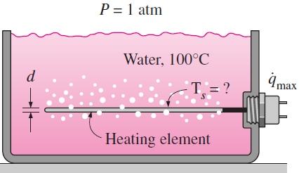

1. Water in a tank is to be boiled at sea level by a 1-cm-diameter nickel plated steel heating element equipped with electrical resistance wires inside, as shown. Determine the maximum heat flux that can be attained in the nucleate boiling regime and the surface temperature of the heater surface in that case.  
   [Ans: Ts = 119oC]
2. A platinum-plated rod with a diameter of 1mm is submerged horizontally in water at atmospheric pressure (see image used for Q2.4). If the surface of the rod is maintained at 10oC above the saturation temperature, determine the nucleate pool boiling heat transfer rate per unit length and the rate of evaporation per unit length (in kg/s.m)  
   [Ans: Q = 4420 kW/m; 1.96x10-3 kg/s.m]
3. A long, 1-mrn-diameter wire passes an electrical current dissipating 3150 W/m and reaches a surface temperature of 126°C when submerged in water at Iatm. What is the boiling heat transfer coefficient? Estimate the value of the correlation coefficient Csf.

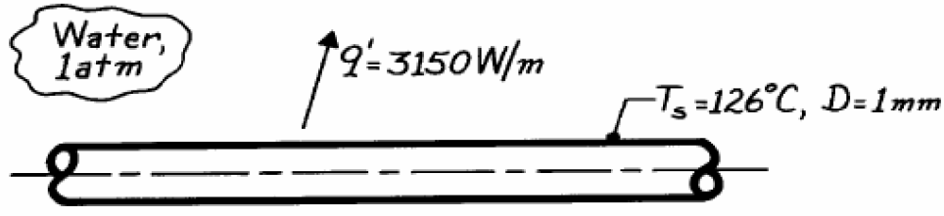

Extra study questions from C&G Textbook  
10-12 [Ans: 19.4 kg/h];

10-13 [Ans: Qboiling=9945W, mevap = 0.00441 kg/s];

10-17 [Ans: Ts = 112.9oC, t = 7.97min]

### Condensation

1. The Reynolds number for condensate flow is defined as $Re=4\dot{m}/pμ_{l}$ (*p* is the wetted perimeter). Obtain simplified relations for the Reynolds number by expressing p and $\dot{m}$ by their equivalence for the following geometries:  
   (a) vertical plate of height *L* and width *W*

(b) a tilted plate of height *L* and width *W* inclined at an angle u from the vertical

(c) a vertical cylinder of length *L* and diameter *D*

(d) a horizontal cylinder of length *L* and diameter *D*, and

(e) a sphere of diameter *D*

1. A vertical 0.2m x 0.2m square plate is exposed to saturated water vapour at atmospheric pressure. If the surface temperature is 80oC and the flow is laminar, estimate the local heat transfer coefficients at the middle and at the bottom of the plate.
2. Saturated steam at 1atm condenses on a 3-m-high and 8-m-wide vertical plate that is maintained at 90oC by circulated cooling water through the other side. Determine (a) the rate of heat transfer by condensation to the plate, and (b) the rate at which the condensate drips off the plate at the bottom. Assume wavy-laminar flow. Is this a good assumption?
3. Consider film condensation on the outer surfaces of N horizontal tubes arranged in a vertical tier. For what value of N will the average heat transfer coefficient for the entire stack of tubes be equal to half of what it is for a single horizontal tube?
4. Saturated ammonia vapour at 10oC condenses on the outside of a 4-cm-outer-diameter, 15-m-long horizontal tube whose outer surface is maintained at -10oC. Determine (a) the rate of heat transfer from the ammonia, and (b) the rate of condensation of ammonia.
5. A horizontal condenser uses a 4x4 array of tubes that have an outer diameter of 5.0cm and length 2.0m. Saturated steam at 101.3kPa condenses on the outside tube surface held at a temperature of 80oC. Calculate the steady rate of steam condensation in kg/h.

Extra study questions from C&G Textbook  
10-59 [Ans: 7032 W/m2; mevap = 0.0872 kg/s];

10-73 [Ans: mevap = 0.0664 kg/s];

10-74 [Ans: 3678 kW; mevap = 1.496 kg/s];